APACE Natural Design

Landscape Design Service

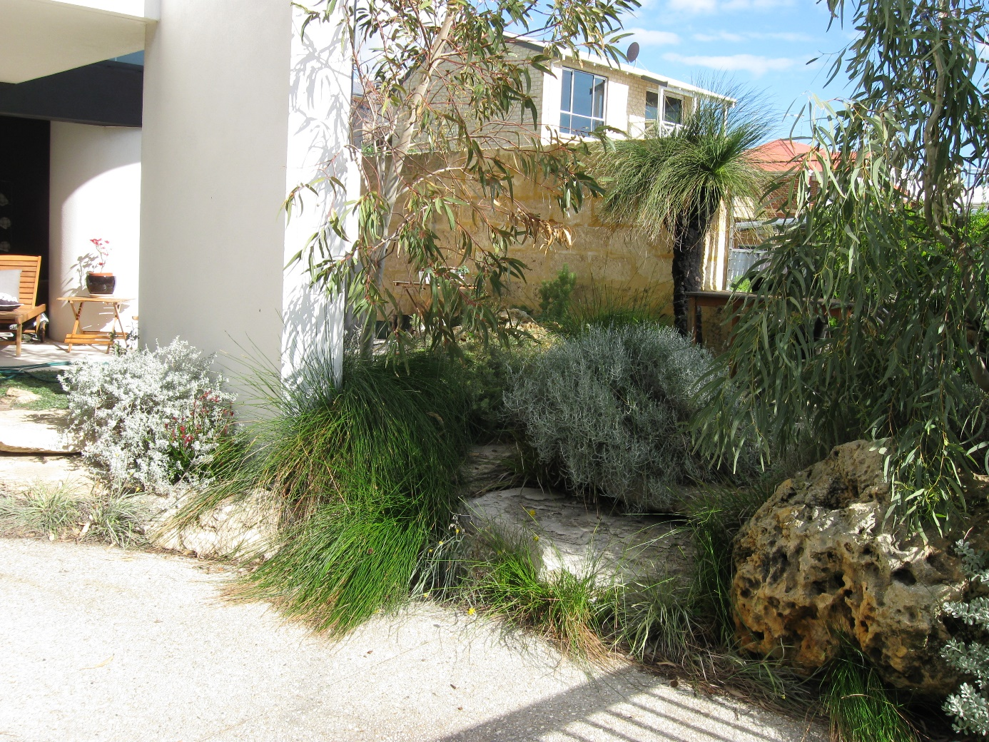

Apace Aid Inc.
2021

CONTENTS

APACE Natural Design 1
Landscape Design Service 1
APACE 3
APACE Natural Design Service 5
Local Plants and Soils 5
Landscape Design Process 7
Implementation 8

17
Karrakatta Vegetation Complex 18
Bassendean Vegetation Complex 21
Bassendean Swamps 23
Southern River Vegetation Complex 25
Vasse Vegetation Complex 29

Complex

APACE
Winter House 1 Johannah Street North Fremantle 6159
Phone: (08) 9336 1262 Email: admin@apacewa.org.au web: www.apacewa.org.au

APACE is a non-profit, community-based organisation located on one hectare of land adjacent to the banks of the Swan River in North Fremantle. The offices are housed in historic Winter House, built in the 1880’s and restored by a community project in the early 1980’s. APACE WA has been resident at Winter House since 1983. APACE is dedicated to helping the disadvantaged within our community by creating a safe venue where people can make positive contributions to their environment. This service has been carried out from the very beginnings of Apace.

Activities undertaken by APACE WA include:

- The APACE Revegetation Nursery specialises in the propagation and supply of plant species indigenous to the Swan Coastal Plain and the Darling Range. Plants from the nursery are used in revegetation and landscaping projects throughout the Perth metropolitan region. The nursery is accredited with the Nursery Industry Accreditation Scheme of Australia (NIASA) and all stock is grown under strict hygienic conditions.

- Each year the nursery produces more than four hundred thousand plants and provides a selection of two hundred and eighty different species that are generally unavailable elsewhere. The APACE nursery was the first West Australian nursery to bring into cultivation a range of common rush and sedge species for wetlands revegetation projects.

- Consultancy services are provided in landscape design, revegetation design and site rehabilitation, including species selection, remedial works, weed eradication and other management issues. Flora and fauna surveys, where required, are also conducted. Clients include government departments, local government, schools, community groups and the private sector.

- APACE provides a comprehensive project management and implementation service. We conduct project management of both large and small-scale revegetation projects. We offer services in landscape architecture, project design, seed collection, planting, fencing and follow-up maintenance works. We also undertake a variety of construction projects including bird hides, boardwalks, beach shelters and dunal fencing.

- Since 1983 APACE has been providing education and training programmes for the community. Many of these programmes have had an environmental focus and have been conducted by APACE throughout Western Australia.

- The Swan Regional Seedbank has been set up by APACE to support our client projects with species indigenous to the Swan Coastal Plain and Darling Scarp and Range. The Swan Regional Seedbank provides a facility that enables community groups to store seed collected from their own reserves. The Seedbank acts as a training and education facility to support collection of indigenous seed material.

APACE Natural Design Service

APACE Natural Design is a landscape design service with a focus on natural, sustainable design that enhances the local ecology while creating calm spaces that help people connect to their local environment and each other.

Our style as ‘naturalistic design”, less oriented to the formal symmetrical, neatly clipped type of look. Good garden design can often go unnoticed, possibly looking “natural” but it just feels right to be in and is functional.

We aim to minimise environmental impact of landscapes by using local materials, reducing waste and aiming to reduce urban heat through promotion of trees and materials that have a low thermal mass. We use materials local to place, for example limestone in the coastal limestone areas and other types of local materials elsewhere (e.g crushed granite or gravel).

Local Plants and Soils

As an environmentally friendly organisation that grows Western Australian plants local to the Perth Region, we are dedicated to using as many local plants as possible. They give a local sense of place and habitat for local animal species. They also have low fertiliser and water use. Apace uses the Soil Vegetation Associations as the basis for species selection in different areas. A map indicating the locations of the different soil types is included to assist with project area identification. Refer to the catalogue of soils for your area for more information and a species list.

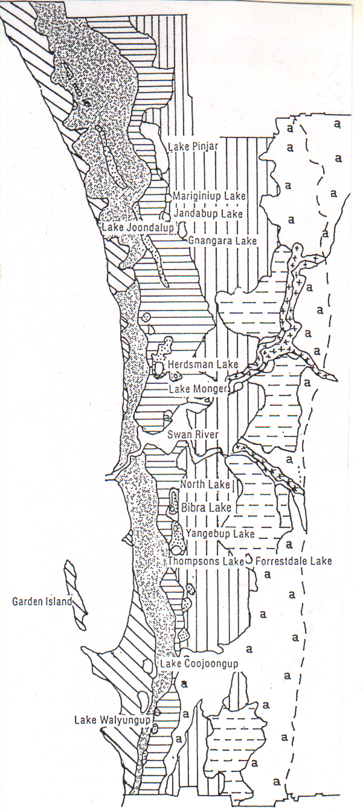
Swan Coastal Plain
Soil Types

Aeolian Soils

Quindalup

Cottesloe

Herdsman

Karrakatta

Bassendean

Aeolian over Alluvial

Southern River

Alluvial

Swan

Other Alluvial
a
MAP
Adapted from “The Atlas of Natural Resources: Darling System, Western Australia” (WA Department of Conservation and Environment). In “Leaf and Branch: Trees & Tall Shrubs of Perth” by Robert Powell, CALM Perth (1991), p. 14.
x
APACE Revegetation Catalogue 2002 Phone: 9336 1262 Fax: 9430 5729 Email: apace@argo.net.au

Landscape Design Process

The APACE landscape design process is outlined below. We start by having a conversation with you about what your needs are. The next step is a site visit consultation where we can review the site, discuss options, think about the timing of works and discuss whether further design work would benefit your project.

We can then provide you with some advice, or we can provide you with a project proposal where we agree the scope, job cost estimate and process.

From there, we create a baseplan using aerial photos or drawings you may already have and a site survey and then produce the design products that you need, which for most projects is a Landscape Plan. For some gardens or larger or more complex projects we can also provide planning drawings, a concept plan to assist discussion of options and cost estimate and overall timing and project schedule can be provided.

APACE usually supply the plants for the designs that we do – we can place a plant order for you based on a plant list/advice or a detailed planting plan and layout.

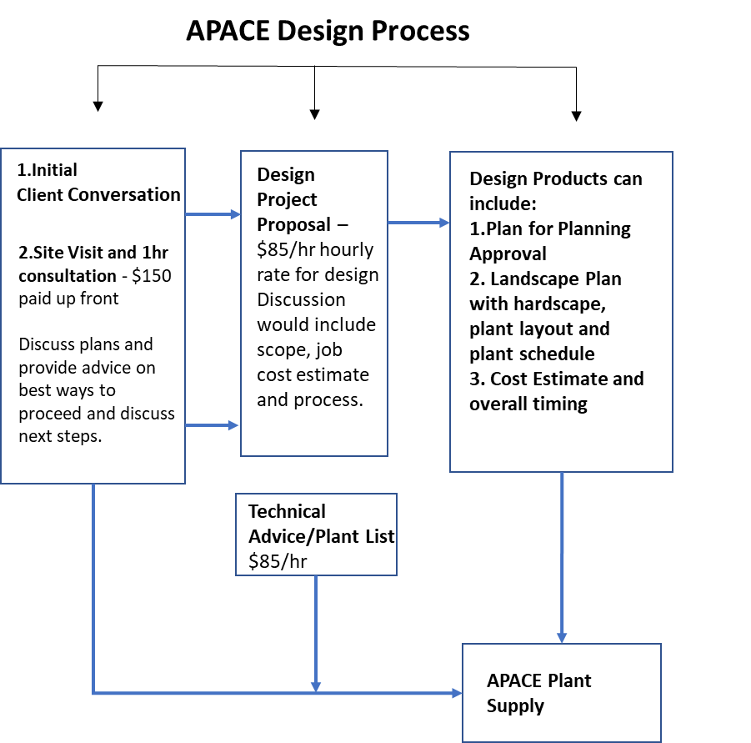

Implementation

Following an APACE design/documentation, we handover to the Client to manage installation, either themselves or using a Landscape Contractor to project manage and install. We can provide you with a list of preferred contractors. We do not do landscaping installations.

As part of our revegetation work, APACE do have a weed spraying service that you may like to engage as part of the site preparation works and we can also provide design support at an hourly rate (but not project management). At the end of the landscape job, we can provide a quote to plant the plants if this is preferred by the Client/Contractor.

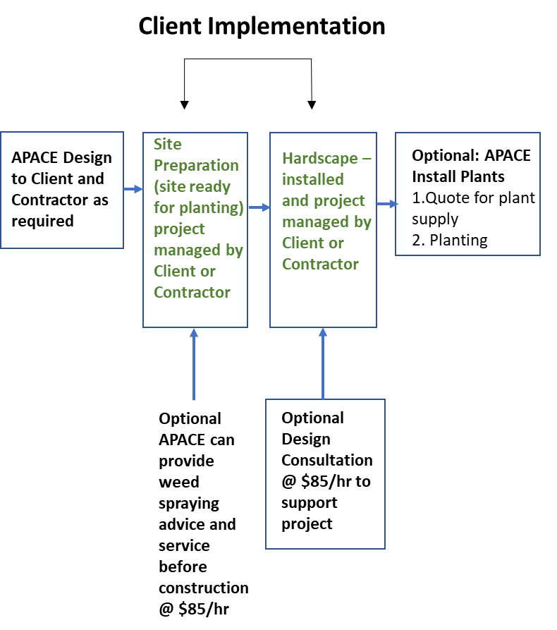

Apace Aid (Inc)
Winters House
1 Johannah Street North Fremantle 6159

Phone 9336 1262
apace@apacewa.org.au
www.apacewa.org.au

